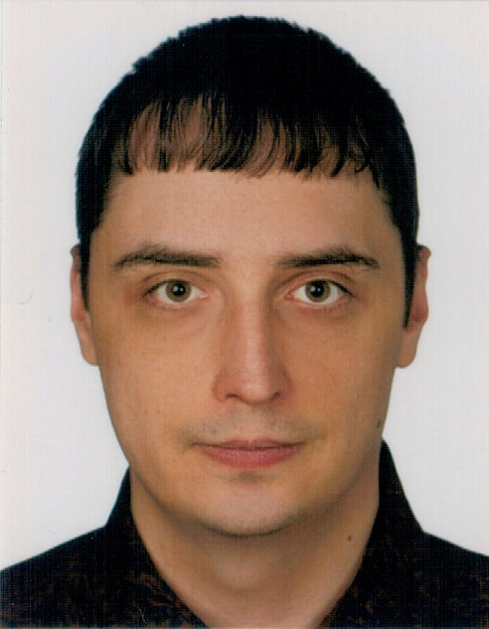 | Konrad Pieczyński    +48 511 134 232    konrad.pieczynski@gmail.com    www.linkedin.com/in/konrad-pieczynski/    konradpieczynski.github.io    github.com/konradpieczynski/
 | Java projects:
About: | • Graduate – placehorder text  • Shop backend – group REST; using jira, online meetings and chat for communication  • Kodilla crud app – REST; task lists and exports to trello api  • Library backed - REST; book/author lists serving  • Tick tack toe – game with variable board size vs multiple computer players  • Sudoku solver – recursive solving program for sudoku  • Rock, paper, scissors, spock, lizard – rock,paper, scissor game with extra move types
Knowledgeable engineering team member with background setting up, maintaining and programming stations. Works well independently and in teams. Expert troubleshooter and critical thinker with great problem-solving abilities.
 | Automotive projects:
Participated in many different projects for Volkswagen, Porsche, Magna. Work included programming, fault finding and hardware diagnostics in both old and new production lines.
Examples:
• new production lines for VW crafter mask, front and rear doors
• modernised production line for VW touareg/Porsche cayanne glue cleaning
• transport lines for VW ID.4
• new production lines for BMW Z8 head protectors
Core qualifications:
• Java
• Spring, Hibernate
• Junit, Mockito
• Gradle
• REST api
• JIRA, GIT
• SQL
• Docker
• VASS v05/v06 Siemens
• Tia portal, Step 7
• MoviTools
• Wincc FlexibleAdvanced
• G1/E, G1/D, G2/E, G2/D, G3/E, G3/D
 | Experience:
 | VI.2023 – current | Test engineer – Bitron poland sp. z o o.
 | III.2023 – V.2023 | Jr specialist automotion electric - Magna Formpol sp. z o o.
 | IV.2022 – II.2023 | Automatican - Jassboard Sp. z o.o.
 | VI.2022 – III.2022 | PLC project menager (3 mos) / control system programmer (2.5 yr) ROLLING-ROBOTICS SP. Z O.O. SP.K.
Languages: | III.2016 – V.2019 | Advanced control system programmer (5 mos) / control system programmer (2.5 yr) / jr programmer (3 mos) Blumenbecker Engineering Polska Sp. z o.o.
• Polish - native  • English - C1  • German - A1+ | III.2016 – V.2019
• Polish - native  • English - C1  • German - A1+ | IX.2014 – II.2016 | Electronic – Huta bankowa Sp. z o.o.
Courses: | Education:
• Intex:  - Basic S7 300/400  - Advanced S7 300/400  • Udemy:  - Docker & Kubernetes: The Practical Guide  - SQL and PostgreSQL: The Complete Developer’s Guide  • Kodilla:  - Java developer plus  - Spring and hibernate from inside  - Multithreading in Java | • 23.I.2012 „Inżynier” (Bsc eq.) Electronics and Telecommunication  Silesia University of Technology in Gliwice

